Looking for a unique and rewarding volunteer experience?
Become a Decisions For Living volunteer tutor.

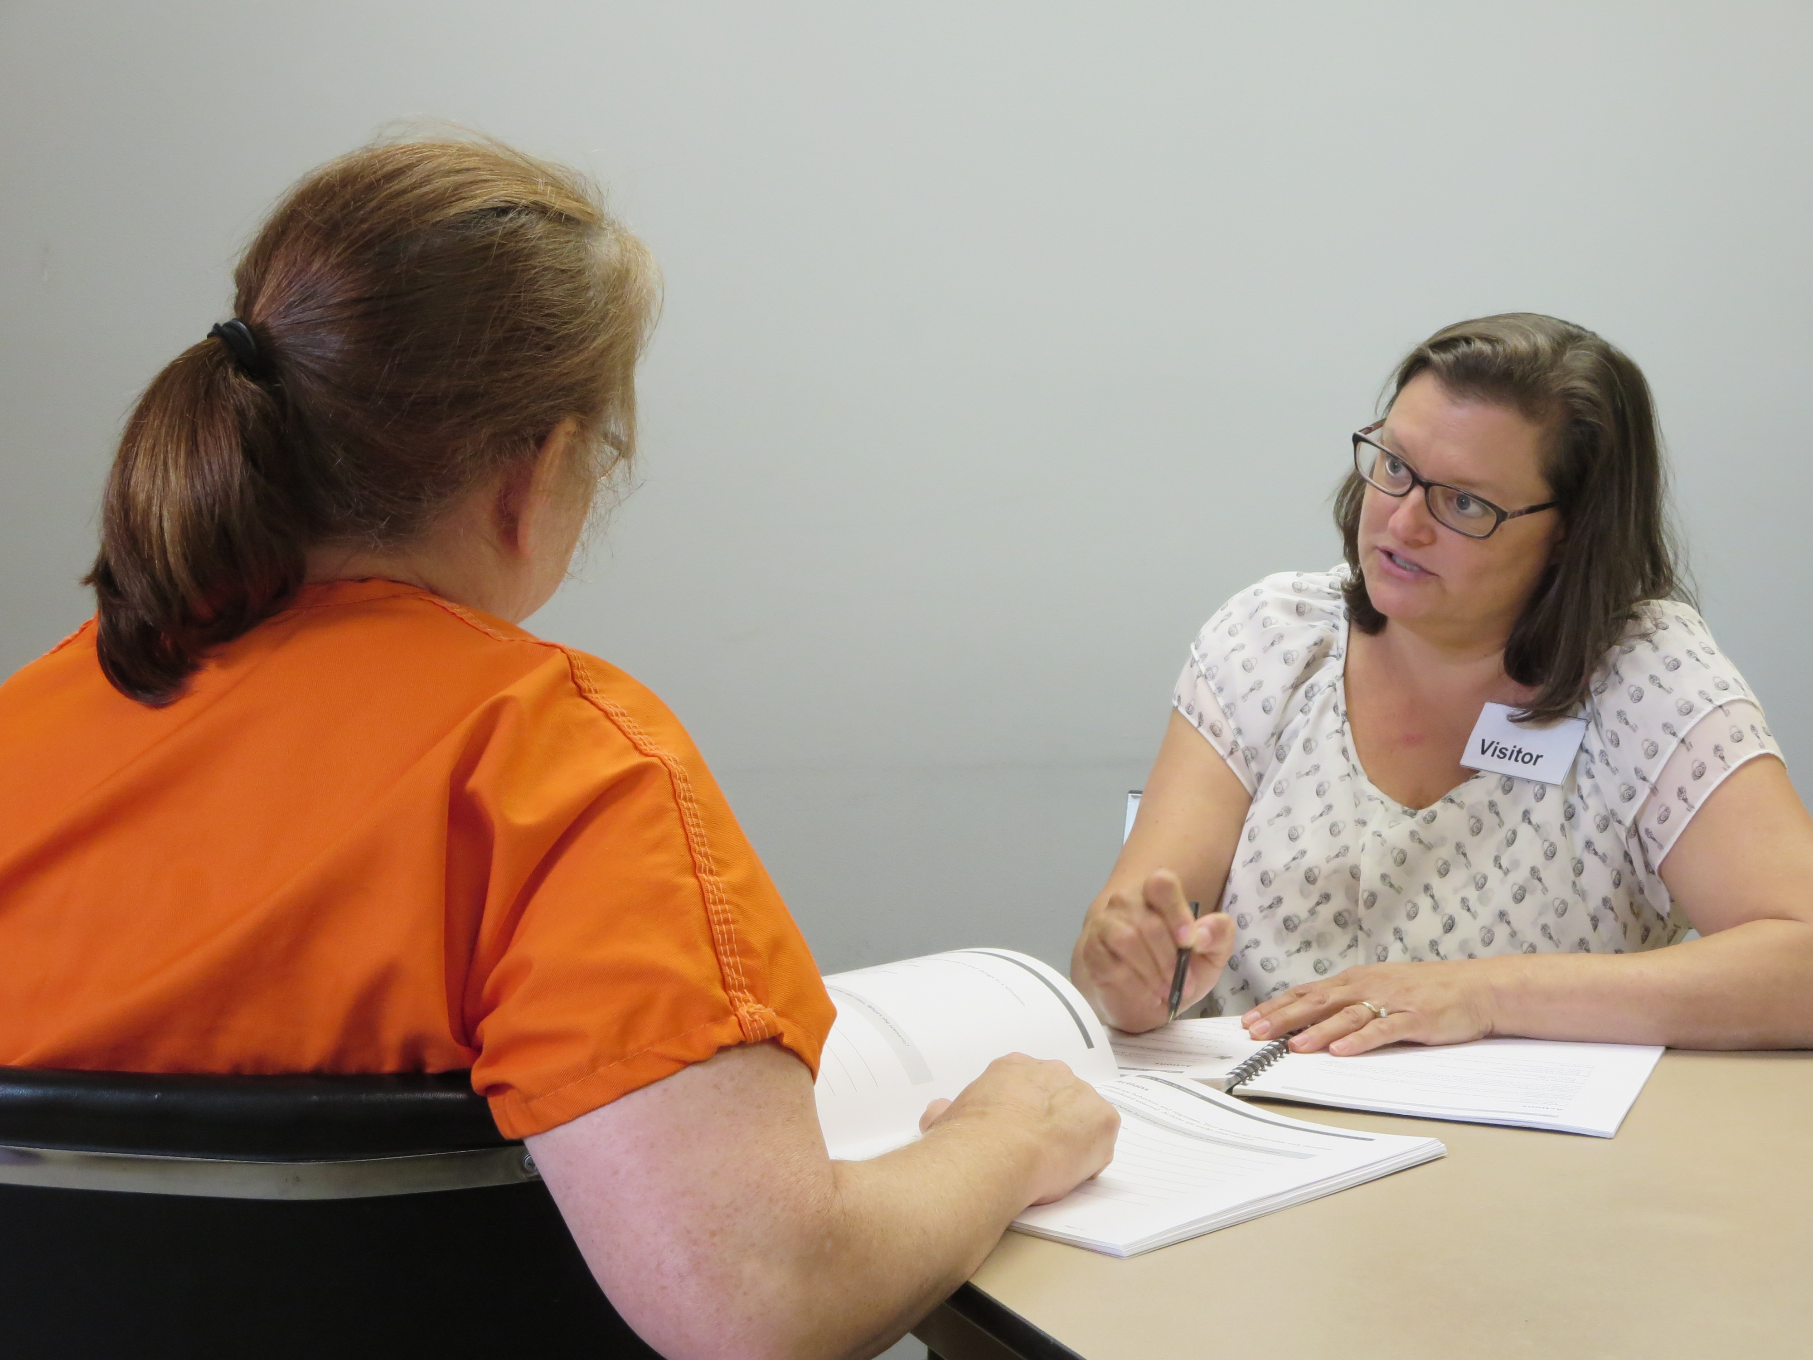

Decisions For Living (DFL) tutors work with men and women in the Bucks County Correctional Facility in Doylestown, teaching a logical five-step decision-making process that emphasizes self-awareness, personal responsibility, critical thinking, and goal setting.
DFL provides clients with tools to help them reintegrate more effectively into the community upon release.

How do I become a tutor?

Completion of the DFL tutor training is required. You will learn Vita’s Decisions For Living process and the necessary techniques to teach the process to your client. A tour of the Bucks County Correctional Facility is part of the training. Criminal record clearance is required.

Fall 2016 Decisions For Living Tutor Training
Date & Time: Thursdays from 6:30 – 9:00 p.m. Nov. 3, 10, 17 and Dec. 1 and 15
Location: Vita Education Services, 8 East Court St., Doylestown

Dec. 8 - tour of Bucks County Correctional Facility.

A donation of $50 is requested.

_ _ _ _ _ _ _ _ _ _ _ _ _ _ _ _ _ _ _ _ _ _ _ _ _ _ _ _ _ _ _ _ _ _ _ _ _ _ _ _ _ _ _ _ _ _ _ _ _ _ _ _ _ _ _ _ _ _ _
Please return to Vita Education Services, 8 East Court St., Doylestown, PA 18901

Email: info@vitaeducation.org Phone: 215-345-8322 Fax: 215-345-8675

I would like to register for the Decisions For Living Tutor Training.

NAME ____________________________________________
STREET _____________________________ CITY _________________ STATE ___ ZIP _______
PHONE ___________________________ E-MAIL ______________________________________
I have enclosed a donation of $ ____

Thank You!


Vita Education Services

www.vitaeducation.org

